Shabbos Stories for
Parshas bamidbar 5781
Volume 13, Issue 37 4 Sivan/May 15, 2021
Printed L’illuy nishmas Nechama bas R’ Noach, a”h

For a free subscription, please forward your request to keren18@juno.com
Past stories can be found on the website ShabbosStories.com
The Unique Zechus
Of the Ridvaz

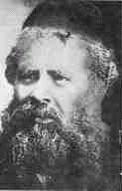

The Ridvaz was the Rav of Slutzk, and was one of the greatest leaders of his generation. One day he became critically ill, and it became clear that his life was hanging in the balance. His Neshamah was brought before the Bais Din Shel Ma’alah, the Heavenly Court, where he was informed that it had been decreed that he pass away before his time, and he was asked to state whether he had any significant Zechisim, merits, that might alter the decree.
The Ridvaz asked the Bais Din if serving as the Rav of Slutzk, one of the largest Jewish communities of the time, was a great enough merit. The Heavenly Court considered this, and concluded that it was not sufficient. Someone else could be the Rav of Slutzk.
The Ridvaz then mentioned that he was in the middle of writing his acclaimed commentary on the Talmud Yerushalmi. If he passed away now, it would not be completed. The Bais Din considered this claim, and then rejected it. There were already a number of other fine commentaries on the Yerushalmi.
In a final attempt to save his life, the Ridvaz argued that every Erev Shabbos, after Chatzos, he had the practice to stop all his weekday activities, and simply sit and eagerly await the arrival of Shabbos. Surely, the sincere longing that he had shown for Shabbos was a great source of merit, he thought. After deliberation, the Heavenly Court accepted this argument, and in this Zechus, the Ridvaz was granted another 30 years of life!

Reprinted from the Parshas Vayigash 5781 email of Torah U’Tefilah as compiled by Rabbi Yehuda Winzelberg.

The Son’s Friend

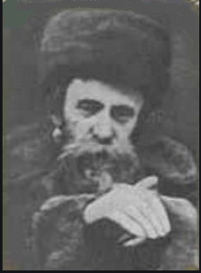

A man once went to see the Admor of Belz, Rav Aharon Rokei’ach, zt”l, and he told the Rebbe about his son, who until that point had done so well in his learning and Avodas Hashem, but recently his son had changed for the worse, and it was greatly distressing him. He asked Rav Rokei’ach what he could do to help his son.
The Rav answered, “Go see who his friends are.”
The man did as the Rebbe instructed, and went to speak with his son’s Rosh Yeshivah, and asked him who his son’s friends are. The Rosh Yeshivah, however, responded that the boys his son was together with were all exceptional students, who took their learning very seriously.
The man went back to Rav Rokei’ach and told him this, but the Rebbe again instructed him to investigate his son’s friends. When the man told him that he had done this already, the Rebbe simply repeated himself, and told him to investigate the friends.

The Son’s Closet Friend was a Troubled Person
The man understood that this was not such a simple matter, and he undertook to investigate his son’s friends a little better. After spending some time on it, he realized that the friend that his son was closest with looked like a righteous individual on the outside, but on the inside, he was a very troubled person with a lot of conflict and had damaging qualities.
After some more work, the man was able to have his son separate from this boy, and he was happy to see his son return to the way he was before, growing in learning Torah and serving Hashem.
The man went back to Rav Rokei’ach to inform him of the good news, and the Rebbe said to him, “After Birchas HaShachar, in Davening, we ask Hashem to help us establish our ways in Torah, and, among other things, to distance us from a Chaveir Ra, a bad friend. Then, immediately in the next paragraph, we repeat this request and ask Hashem to save us today and every day from a Chaveir Ra, a bad friend. What is the reason for saying this twice? The answer is that when it comes to dealing with friends that are a bad influence, asking only one time is not enough. We have to ask Hashem for help twice to save us!”

Reprinted from the Parshas Vayigash 5781 email of Torah U’Tefilah as compiled by Rabbi Yehuda Winzelberg.

Rav of Komemiyus: Part Three

Whoever was privileged to see R’ Binyomin Mendelson speaking publicly about shmittah could visibly sense how he was filled with the holy “additional soul” for the “Shabbos of the land.”
Even people who were far removed from keeping these laws were inflamed by R’ Binyomin’s passion, and were soon keeping these very mitzvos. When he was once addressing a crowd about the topic of shmittah relating to an orchard on Komemiyus, some of the people remarked amongst themselves, “One thing is clear to us. R’ Mendelson does not need his orchard for the six years (preceding shmittah) save to dedicate it in the seventh year for the mitzvah of shmittah!”
R’ Binyomin viewed the mitzvah of shmittah as a unique opportunity of serving Hashem with the joy of a mitzvah – one that only residents of Eretz Yisroel are privileged to fulfill. People recall the exhilaration and joy on R’ Binyomin’s countenance at the start of Rosh Hashana of a shmittah year.
The year of shmittah was to R’ Binyomin like one long Yom Tov. Under R’ Binyomin’s leadership and guidance, those who lived and worked the land at Moshav Komemiyus were instilled with the clear view that the land belongs wholly to Hashem. The farmers and workers on Komemiyus – many of whom were devout chassidim and Torah scholars – went about their manual labors with the absolute faith that they were performing holy tasks.
R’ Binyomin assured that the atmosphere on Komemiyus was imbued with this unshakable faith. Due to R’ Binyomin’s influence, it was a way of life on Komemiyus. Once, a number of new settlers joined Moshav Komemiyus and portions of land were to be allotted to them. It was decided to allot them portions of land from a new section of fields.

Veteran Moshav Settlers are Upset
Some of the veteran settlers convened a meeting in protest of the fact that these new settlers would thus be receiving a larger piece of land than the veterans had! R’ Binyomin suddenly appeared at the meeting and began to address them. He did not speak of the halachic aspect of the issue at hand.
He rather angled his words from the standpoint of faith and trust, saying, “If it was decreed on Rosh Hashana that you will earn a certain sum, is it ‘difficult’ for Hashem to allow you to earn that sum from a smaller piece of land? Why should you then want to exert yourself with more work on a larger piece of land for that same sum?!”
The assembled were swept away with the fiery faith which he instilled in them, until they were confident in the mercies of Hashem Who sustains each person accordingly. Not another complaint was voiced about the land allotment.

The Power to Inspire Faith in His Community
Such was the power of R’ Binyomin Mendelson! Just as he implanted faith in his community, so too did R’ Binyomin instill within them fear of Heaven and love of fellow Jews. When R’ Binyomin ascended with his community to Yerushalayim on the Three Yomim Tovim (Pesach, Shavuos and Sukkos), he would remind them, as they approached the Kosel, that they were drawing closer to the place from which the Divine Presence has never left.
“My dear brothers!” he would say. “Now is not the time to pray for children, health and sustenance, nor for any other matters pertaining to this world or the next world. Now we must only plead that Hashem should reveal the glory of His Kingdom very soon, for we need nothing save that!”
During one of the wars fought by Israel, one of the residents of Moshav Komemiyus was drafted into active duty. No word was heard about him for a long time, and all the people on the Moshav were worried about his welfare. One day the man simply showed up in the shul at Komemiyus right before mincha, and came right up to greet R’ Binyomin.

Instructions for the Chazzan
The chazzan had already stood up to start “Ashrei,” however, R’ Binyomin, out of his sheer and overwhelming joy in seeing the man return safe and sound, told the chazzan to begin the prayers with “Hodu L’Hashem Ki Tov” (give praise to Hashem for He is good). R’ Binyomin told the entire congregation to say “Hodu” as well. R’ Binyomin explained to the perplexed people, “A member of our congregation returned alive and well from a cauldron of fire….” Everyone rejoiced with R’ Binyomin, for his joy was contagious.
Once, the man who ran the bakery on Komemiyus, came to R’ Binyomin to explain that the bakery is suffering from financial losses and it would be necessary to close it down. R’ Binyomin begged him to please keep it running for a few more months, as it would enable many surrounding settlements to receive and eat kosher bread, which would otherwise not be available to them.
The man agreed. After three months, the man returned to R’ Binyomin to report that the financial losses were more than they could bear. R’ Binyomin tried to convince him to keep the bakery open for another three months so that many people could benefit from kosher bread. The man put the bakery keys on the desk and said that someone else should be appointed to run the bakery, as he could not continue under such circumstances.

Offers His Merit in the World to Come
R’ Binyomin did not relent. He tried to convince him, with deep emotion, until he finally said, “I will give you my merit in the world to come for the ten best Chiddushei Torah that I formulated, if you will keep the bakery open for at least another three months so that Jews can eat kosher bread.”
There is a common thread that runs through all of R’ Binyomin’s actions – total devotion to fulfilling the Will of Hashem and bringing honor to Hashem’s Name. A strong fire burned within his soul – a fiery love for his Creator. He led his life in purity and utter sincerity. He was beloved and accepted by all segments of Jewry – in Eretz Yisroel and throughout the world. He led his “flock” with strength and dignity, and was like a father to each of his community members. He brought many people closer to Torah and mitzvos.
He was a Rav who resembled an angel living on this mortal earth. (Marbitzei Torah Me’Olam HaChassidus, Vol. 8) The yahrzeit of R’ Binyomin ben R’ Menachem Mendel Mendelson zt”l is on 24 Iyar (1979). May his merit protect us.

Reprinted from the Parshas Acharei Mos-Kedoshim 5781 email of The Weekly Vort.

The Taxi Driver and the Holocaust Survivor
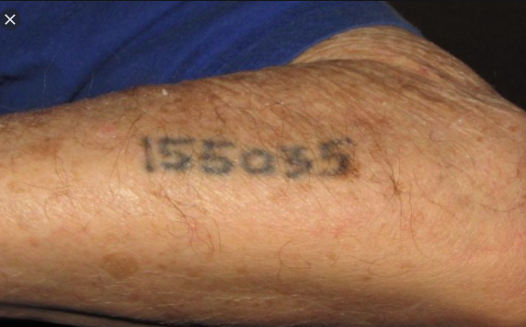

Rabbi David Ashear wrote a story in Living Emunah 5 about loyalty between siblings. Shlomo, a taxi driver in Israel picked up a distinguished looking man in need of a ride from the airport. As they drove toward their destination, the passenger casually rolled up his sleevs. “It’s warm in here, right?” he asked conversationally. Shlomo glanced over, and when he saw the man’s arm, he gasped. “Are you all right?” the passenger asked, noting Shlomo’s distress.
Shlomo proceeded to tell him a story. “Years ago, I worked on a kibbutz. My job was sorting apples. I would put the good apples in one pile, to be sold, and throw the lower quality apples into a giant blender to make juice. One day, I had an urge to see how the blender worked.
After filling it with bruised apples, I climbed up to the top to watch the apples get chopped. Suddenly, I lost my balance and fell into the deep vat. The machine was running, and I had very little time before the blades would strike me. I began to scream. Right in the nick of time, I felt someone grab me. He pulled me out and saved my life. I thanked him profusely from the bottom of my heart. From that day forward, we became friends.”
“On occasion,” Shlomo continued, “I noticed my new friend would seem depressed. One day, I gathered the nerve to pry and asked him what was bothering him. He told me he was a Holocaust survivor. He and his only brother went through the war together before he was taken away. ‘I haven’t seen him since,’ my friend said. ‘Sometimes I think about him and I get really sad, remembering how close we were.’”
Shlomo said to the passenger, “He showed me the number on his arm, 5034. His brother’s number was one higher, 5035. It has been about ten years since my friend told me that story. He still gets sad about his long-lost brother. I’ll never forget that number. You just raised your sleeve and it’s there! 5035!!”
Shlomo drove his passenger straight to his friend’s home and let his tears flow unchecked as he watched the brothers’ emotional reunion. This episode was orchestrated by Hashem for many years, showing us the loyalty of a sibling is unmatched.

Reprinted from the Parashat Acharei Mot/Kedoshim 5781 based on the teachings of Rabbi Amram Sananes as written by Jack E. Rahmey.

The Memory of a Young Yerushalmi Masmid

Rav Yosef Shalom Elyashiv, zt”l, had unparalleled Hasmadah, diligence in learning Torah. Once, an older tourist traveled to Yerushalayim from abroad, but he was in fact originally from the holy city of Yerushalayim, and had returned for a trip to his childhood home in Mei’ah She’arim. For hours, the gentleman wandered the familiar streets and alleyways of his youth with his family, reminiscing, “This was the shop of so and so, here is the Shuk, there are the Shteiblach, everything in Mei’ah She’arim is the same as it was when I left forty-six years ago! Only the people have changed. Generations have come and gone!”
The man continued walking with his children and grandchildren, proudly taking it all in. At one point, he stopped and pointed. “I remember this place. This is the Ohel Sarah Bais Medrash. It looks exactly the same as I remember it from my childhood.”
The man walked inside. “You know, many years ago, when I was a kid, there was a young man, a really special person, who sat in this Bais Medrash here and learned with an incredibly sweet tune. We children used to love listening to the sound of his learning. If only there would be such Masmidim nowadays! I wonder where that young man is today. I wonder where he lives and what he is doing now.”
The tourist entered the Bais Medrash and saw an elderly man with a white beard, learning out loud with a pleasant tune. He walked over and said, “Excuse me, Reb Yid, I’m trying to remember, over forty years ago there was a young man who sat here and learned in exactly the same spot you’re sitting in. He was really special, always sitting and learning. Nothing disturbed him. Perhaps you remember him? I’m very curious to find out where he is today.”

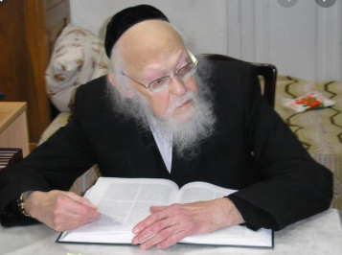

The old man raised his hand dismissively and continued learning. The tourist stood on the side, listening to him learn as old memories washed over him. Suddenly, the truth dawned on him, that he was speaking to the same person who he had seen learning there so long ago, and that he was now in fact the Gadol HaDor, Rav Yosef Shalom Elyashiv!
He said, “I don’t believe it! It’s him! It’s the same tune! It’s the same learning!” He couldn’t contain his amazement, and when he got back outside, he exclaimed, “Nothing has changed at all in Mei’ah She’arim in the past forty-six years! Even the Masmid who sits and learns in Ohel Sarah is the same one, exactly as he did back then!”

Reprinted from the Parshas Vayigash 5781 email of Torah U’Tefilah as compiled by Rabbi Yehuda Winzelberg.

The Religious Jewish Artist
By Rabbi Dovid Goldwasser

A young man who grew up in a religious family developed an interest in the world of art. Unfortunately, the people with whom he shared this interest, and with whom he associated, were of low moral character, and many would consider some of their activities depraved. Certainly, their values were antithetical to what he had learned in yeshiva.
The young man’s personal conduct slowly began to deteriorate as practices that had at one time been abhorrent to him became acceptable. Eventually he was at the point of marrying a woman out of the faith.
His mother, a very upright person deeply committed to Torah and mitzvos, was distraught. Her world was destroyed and she walked around in a daze. All her efforts to change the situation were to no avail.
The great tzaddik of Kapishnitz was still living at that time, and the mother felt that perhaps he would be able to help her. After many attempts, she finally found herself in the study of the Kapishnitzer Rebbe. As soon as she opened her mouth to speak, she choked up and began to cry bitterly.
The Kapishnitzer Rebbe, known for his great ahavas Yisrael, listened to the mother pouring out her heart and was deeply moved. He was unable to calm her down until he promised her that her son would abandon his current lifestyle and return to the fold very soon.
And so it was. Within a short amount of time, the son unexpectedly came home. He related that he had been overwhelmed by thoughts of teshuvah and had a sudden desire to return to his roots. Everyone who heard about this startling development was amazed and believed the Rebbe had wrought a great miracle.
But when someone attributed ruach hakodesh to the Rebbe for seeing the future, the Kapishnitzer saod, “It was not me, and not even a part of me. I had no idea or any inkling that the son would do teshuvah. But when I saw the mother’s deep pain, I decided that I would make this promise just to calm her down so that she wouldn’t grieve so strongly.
“However, later I realized that a chillul Hashem would result if my promise didn’t prove true. I therefore pulled myself together and spent time every day praying, begging and crying to Hashem to have mercy on the young man and place thoughts of teshuvah in his mind so that the Name of Heaven shouldn’t be desecrated. Hashem, in His great mercy and compassion, heard my prayers.”

Reprinted from the April 22, 2021 website of The Jewish Press.

The Giant Little Mitzvahs
Adapted from the teachings of Rav Avigdor Miller z"l
By Ari Ben-Ami

Basya sat at the dining room table, frowning at her Chumash homework. At the other end of the table, Yitzy was chazering (reviewing) the gemarah he learned in school that day, while Totty tested Shimmy on Mishnayos baal-peh.
“Basya, is everything okay?” asked Mommy as she walked in from the kitchen.
“I don’t know,” Basya said, still staring at the paper in front of her. “Usually I am able to figure out the answer to Morah Esty’s extra-credit question, but I’m stumped on this one.”
“What’s the question?” asked Mommy.
Basya looked up. “The Torah says that someone who eats blood gets koreis (spiritually cut off from the Jewish nation), the worst punishment in the Torah. Why does eating the blood of a kosher animal deserve such a terrible onesh?” “Hmmm,” said Mommy. “That sounds like a tough questison. But dinner is ready now in the kitchen. Why don’t we think it over as we eat?”
Followed by Totty and the boys, Basya and Mommy walked to the kitchen to eat the hot supper of spaghetti and meatballs that Mommy had prepared. Everyone made beautiful brachos and ate the delicious and healthy food.
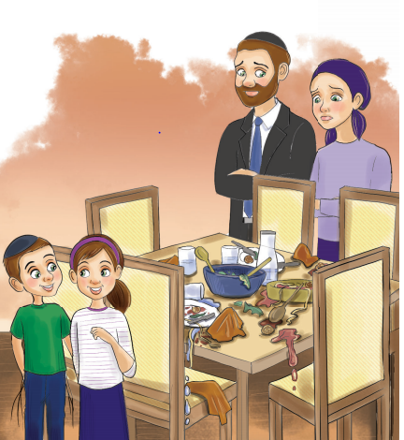
Illustration by Yocheved Nadell

“Thank you so much for the delicious supper, Mommy,” said Yitzy as he got up and carried his plate to the sink. “I’m going to shul to learn with Avrumy. I’ll see you later!”
Basya and Shimmy got up as well, thanked Mommy and started leaving the table.
“Basya, Shimmy,” called Mommy. “Aren’t you forgetting something?” Basya and Shimmy stopped, confused. What did they forget? Maybe Mommy was going to serve chocolate cake for dessert? Mommy and Totty frowned at the childrens’ blank stares.
“You really don’t know what you forgot?”
“No…” said Basya slowly. It didn’t seem like they were about to get a treat. In fact, it felt like they were about to get into trouble for something.
“Look at the table,” said Totty. “Do you see the mess you left here? You are big children, you should know better than to just run away from the table leaving your dirty plates here for Mommy to clean up.”
“I’m sorry,” mumbled Basya as she and Shimmy quickly went and took their plates to the sink.

We Would Expect Better from Such Kinderlach like Yourselves
“Thank you,” said Mommy. “You know we’re quite surprised that you children are still forgetting to clean up after yourselves. We would expect better from such good kinderlach like yourselves.”
Basya and Shimmy looked down at the floor. “We’re so sorry, Mommy. We will make sure to be more careful going forward.”
After a moment, Basya continued, “but can I ask a question? I feel like you were really upset at us for this. I understand it’s important and we should try harder to clean it up, but why are you so upset about something so small like carrying one plate to the sink?”
Mommy continued to smile. “Isn’t that just it, Basya? If it’s so easy to do, in a way it’s worse than something that is hard. Because what is stopping you from doing it if it’s so simple?”
Something suddenly clicked in Basya’s brain.
“Wait! I think that’s the answer to Morah Esty’s question! Because who wants to eat blood? It’s disgusting - I can’t imagine it tastes very good. So if someone can’t even keep an easy little mitzvah like not to eat blood, then maybe that’s why the Torah gives such a big punishment - because there’s no excuse for not keeping an easy mitzvah like that.”

That which is Easier to Avoid has a Greater Punishment
“What a great answer!” exclaimed Totty. “And you’re not going to believe this, but that is exactly what Rav Avigdor Miller says about the issur to eat blood! Because it is so easy to avoid, that’s why the punishment is greater. That’s why we need to be extra careful to make sure we’re not doing something wrong, especially if it’s such an easy thing to not do. And the same goes for mitzvos that are super easy to do. Why would you want to miss out on getting schar (reward) when it takes so little effort?”
Basya grinned from ear-to-ear. “Thank you, Mommy and Totty, for teaching us this important lesson. I will make sure going forward to always keep an eye out for little mitzvos that I might accidentally overlook.”
Basya paused and then walked back to the table. She picked up the empty salad bowl and water pitcher and carried them to the counter, so excited to get another “easy” mitzvah!

Reprinted from the Parshas Acharei Mos-Kedoshim email of Toras Avigdor Junior

Healed by the Talmud Class
By Hillel Baron

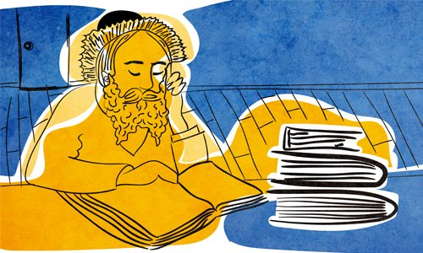

A Jew living in Poland was suffering from a lung ailment, from which his doctors informed him he would not survive. They said that he’d better just relax and settle his affairs, while awaiting his inevitable, imminent death.
But the man refused to cede to such harsh judgment, and began making his rounds among famous, holy rabbis, seeking their blessing for a recovery.
One rabbi he met said: “I cannot assure you recovery. But, I have a colleague living in Selish, in Hungary’s Carpathian Mountains,¹ named Rabbi Shmuel Shmelke.² He and I studied together under the famed Choze (“Seer”) of Lublin. He can help you.
“Do not leave him without receiving an assurance that you will recover. Even if it means sticking around there for a few months, do so, and participate in the classes he gives to the yeshivah students.”
The Jew did as he was told, and traveled to Hungary to seek the great rabbi’s blessing. The rabbi questioned why he had come. “I cannot give you any better assurances,” he said.
The Jew remembered what the first rabbi had told him, and he found himself accommodations for an extended stay. As instructed, he attended the rabbi’s classes at the yeshivah.
One day, the rabbi delivered a Talmud class about the exact lung ailment that this man was experiencing, and quoted the opinion of the foremost commentator on the Talmud, Rashi, who mentions that this ailment is considered fatal. Then the rabbi said, “One moment, there is also the opinion of Rabbeinu Tam ( Rashi’s grandson), who says seemingly in passing that even though this ailment is considered fatal in an animal, it is not considered fatal in a human. This is because a person possesses a mazal (a personal, heavenly, supportive power”).
After saying this, the rabbi turned to the Jew and said: “Do you hear? Rabbeinu Tam assures you that you will have a long life. Go home. You will be well.”
The man went home and lived a long and happy life.
*What can this story teach me about faith? What can it teach me about the power of perseverance even in the face of issues which seem irreversible?
(Source: Tzaddikim Lemofet, pg. 186)

FOOTNOTES
1. This was the name used by the Jewish population. Its Hungarian name was Nagyszőlős. It is currently a city in Ukraine, named Vynohradiv.
2. Rabbi Shmuel Shmelke Klein of Selish, lived from 1805-1875. He was commissioned as a rabbi in 1833, and then established a yeshivah.

Reprinted from the Parshat Emor 5781 email of Chabad.Org Magazine.

19th Century Italian Gold Marriage Ring

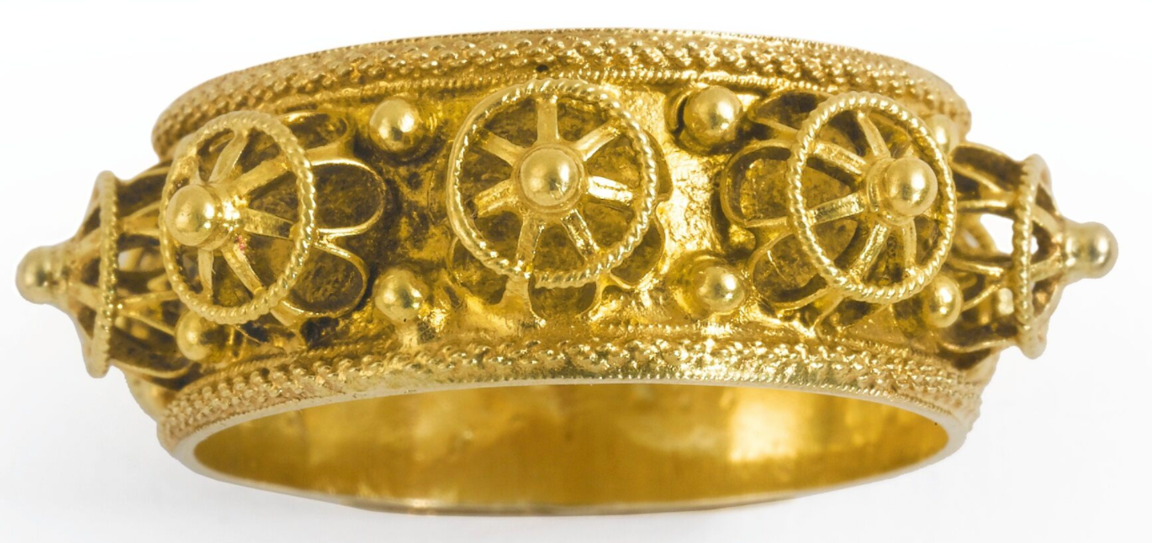

Reprinted from the 2012 Judaica Auction Catalogue of Sotheby’s in New York.

